**Installation of the Managerial Application**

Deployment of the Application involves downloading of both the application and of MySQL software to initialize a local host server for database interaction.

1. Download the Managerial Application Software and choose the location of its files
2. Download the MySQL installer with your computer’s specifications with this link: <https://dev.mysql.com/downloads/mysql/>

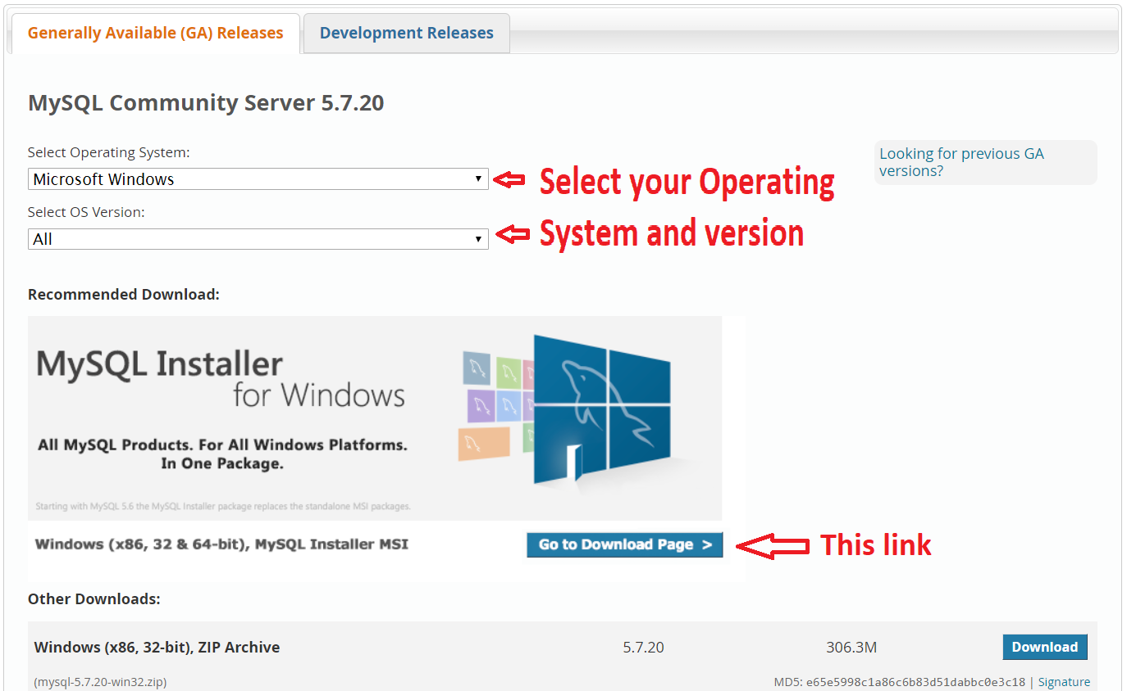

1. 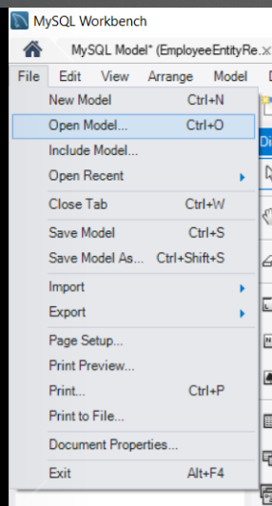When finished, click the MySQL installer and go through the initialization process with next or execute options and using default settings, configure the router and make a password
2. Once installed, open the database MWB file found from the Managerial Application App files through MySQL by going to File -> Open Model -> Select MWB file from file system
3. 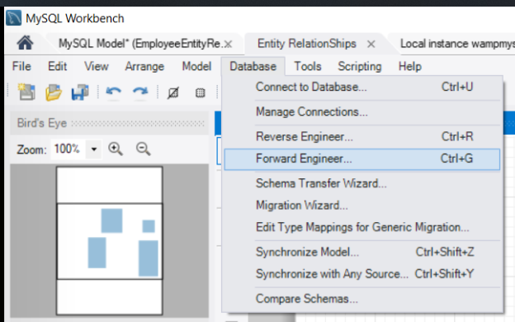Access the manager options by going through the forward engineering process by going to Database -> Forward Engineer
4. Start the Managerial Application app from your program files (or wherever the app was located in the its initialization)
5. Enjoy the software!